Appendix D - Hackney Carriage Vehicle Conditions

Zone 4 - District previously known as the Borough Council of Wellingborough

In the area of zone 4 (previously known as the Borough of Wellingborough), all newly licensed hackney carriages shall comply, in all respects, with the conditions of licensing set out within Appendix D of this policy.

Hackney carriage plate numbers 1-29 are currently reserved for yellow saloon / estate / multi-purpose vehicles with grandfather rights. These grandfather rights are for five years and are provided for only those vehicles currently licensed with the Council. These grandfather rights do not include vehicles subject to change of ownership during this period.

Provisions Fixing the Stands of Hackney Carriages

Within zone 4 there are hackney carriage stands in the following locations:

24 hour ranks:
- Orient Way, Wellingborough;
Main Rank 6 vehicle spaces
Overflow Rank 4 vehicle spaces
- Commercial Way, Wellingborough 2 vehicle spaces

Night-time only ranks:
- Sheep Street, Wellingborough 2 vehicle spaces

- Silver Street, Wellingborough 2 vehicle spaces

Fares Table

Applications for an increase in fares are to be submitted to the Licensing and Appeals Committee for consideration and determination.

Section 67 of the 1976 Act provides that when licensed hackney carriages are used in the district of zone 4 for private hire/hackney carriage purposes, the fares charged shall not be greater than as prescribed in the approved Fares Table.

Byelaws

The byelaws made under Section 68 of the Town Police Clauses Act 1847 and Section 171 of the Public Health Act 1875, by the Borough Council of Wellingborough apply to hackney carriages in zone 4. These are reproduced below.

Zone 4 Byelaws

Made under section 68 of the Town Police Clauses Act 1847, and section 171 of the Public Health Act 1875, by the council of the Borough of Wellingborough with respect to hackney carriages in the Borough of Wellingborough

Interpretation

- Throughout these byelaws “the Council” means the Council of the Borough of Wellingborough and “the district” means the Borough of Wellingborough

Provisions regulating the manner in which the number of each hackney carriage corresponding with the number of its licence, shall be displayed

- (a) The proprietor of a hackney carriage shall cause the number of the licence granted to him in respect of the carriage to be legibly painted or marked on the outside and inside of the carriage, or on plates affixed thereto.

  - A proprietor or driver of a hackney carriage shall:-

    - not willfully or negligently cause or suffer any such number to be concealed from public view while the carriage is standing or plying for hire; and
    - not cause or permit the carriage to stand or ply for hire with any such painting marking or plate so defaced that any figure or material particular is illegible.

Provisions regulating how hackney carriages are to be furnished or provided

- The proprietor of a hackney carriage shall:-

- provide sufficient means by which any person in the carriage may communicate with the driver;

- cause the roof or covering to be kept water-tight;

- provide any necessary windows and a means of opening and closing not less than one window on each side;

- cause the seats to be properly cushioned or covered;

- cause the floor to be provided with a proper carpet, mat or other suitable covering;

- cause the fittings and furniture generally to be kept in a clean condition, well maintained and in every way fit for public service;

- provide means for securing luggage if the carriage is so constructed as to carry luggage;

- provide an efficient fire extinguisher which shall be carried in such a position as to be readily available for use; and

- provide at least two doors for the use of persons conveyed in such carriage and a separate means of ingress and egress for the driver.

- The proprietor of a hackney carriage shall cause the same to be provided with a taximeter so constructed, attached and maintained as to comply with the following requirements, that is to say:-

- the taximeter shall be fitted with a key, flag or other device the turning of which will bring the machinery of the taximeter into action and cause the word “HIRED” to appear on the face of the taximeter;

- such key, flag or other device shall be capable of being locked in such a position that the machinery of the taximeter is not in action and that no fare is recorded on the face of the taximeter;

- when the machinery of the taximeter is in action there shall be recorded on the face of the taximeter in clearly legible figures, a fare not exceeding the rate or fare which the proprietor or driver is entitled to demand and take for the hire of the carriage by time as well as for distance in pursuance of the tariff fixed by the Council;

- the word “FARE” shall be printed on the face of the taximeter in plain letters so as clearly to apply to the fare recorded thereon;

- the taximeter shall be so placed that all letters and figures on the face thereof are at all times plainly visible to any person being conveyed in the carriage, and for that purpose the letters and figures shall be capable of being suitably illuminated during any period of hiring; and

- the taximeter and all the fittings thereof shall be so affixed to the carriage with seals or other appliances that it shall not be practicable for any person to tamper with them except by breaking, damaging or permanently displacing the seals or other appliances.

Provisions regulating the conduct of the proprietors and drivers of hackney carriages plying within the district in their several employments, and determining whether such drivers shall wear any and what badges

- The driver of a hackney carriage provided with a taximeter shall:-

- when standing or plying for hire, keep the key, flag or other device fitted in pursuance of the byelaw in that behalf locked in the position in which no fare is recorded on the face of the taximeter;

- before beginning a journey for which a fare is charged for distance and time, bring the machinery of the taximeter into action by moving the said key, flag or other device so that the word “HIRED” is legible on the face of the taximeter and keep the machinery of the taximeter in action until the termination of the hiring; and

- cause the dial of the taximeter to be kept properly illuminated throughout any part of a hiring which is between half-an-hour after sunset and half-an-hour before sunrise, and also at any other time at the request of the hirer.

- A proprietor or driver of a hackney carriage shall not tamper with or permit any person to tamper with any taximeter with which the carriage is provided, with the fittings thereof, or with the seals affixed thereto.

- The driver of a hackney carriage shall, when plying for hire in any street and not actually hired:-

- proceed with reasonable speed to one of the stands appointed by the Council;

- if a stand, at the time of his arrival, is occupied by the full number of carriages authorised to occupy it, proceed to another stand;

- on arriving at a stand not already occupied by the full number of carriages authorised to occupy it, station the carriage immediately behind the carriage or carriages on the stand and so as to face in the same direction; and

- from time to time, when any other carriage immediately in front is driven off or moved forward cause his carriage to be moved forward so as to fill the place previously occupied by the carriage driven off or moved forward.

- A proprietor or driver of a hackney carriage, when standing or plying for hire, shall not make use of the services of any other person for the purpose of importuning any person to hire such carriage.

- The driver of a hackney carriage shall behave in a civil and orderly manner and shall take all reasonable precautions to ensure the safety of persons conveyed in or entering or alighting from the vehicle.

- The proprietor or driver of a hackney carriage who has agreed or has been hired to be in attendance with the carriage at an appointed time and place shall, unless delayed or prevented by some sufficient cause, punctually attend with such carriage at such appointed time and place.

- A proprietor or driver of a hackney carriage shall not convey or permit to be conveyed in such carriage any greater number of persons than the number of persons specified on the plate affixed to the outside of the carriage.

- If a badge has been provided by the Council and delivered to the driver of a hackney carriage he shall, when standing or plying for hire, and when hired, wear that badge in such position and manner as to be plainly visible.

- The driver of a hackney carriage so constructed as to carry luggage shall, when requested by any person hiring or seeking to hire the carriage:-

- convey a reasonable quantity of luggage;

- afford reasonable assistance in loading and unloading; and

- afford reasonable assistance in removing it to or from the entrance of any building, station or place at which he may take up or set down such person.

Provisions fixing the rates or fares to be paid for hackney carriages within the district and securing the due publication of such fares

- The proprietor or driver of a hackney carriage shall be entitled to demand and take for the hire of the carriage the rate or fare prescribed by the Council, the rate or fare being calculated by a combination of distance and time unless the hirer express at the commencement of the hiring his desire to engage by time.

Provided always that where a hackney carriage furnished with a taximeter shall be hired by distance and time the proprietor or driver thereof shall not be entitled to demand and take a fare greater than that recorded on the taximeter, save for any extra charges authorised by the Council which it may not be possible to record on the face of the taximeter.

- (a) The proprietor of a hackney carriage shall cause a statement of the fares fixed by council resolution to be exhibited inside the carriage, in clearly distinguishable letters and figures.

(b) The proprietor or driver of a hackney carriage bearing a statement of fares in accordance with this byelaw shall not willfully or negligently cause or suffer the letters or figures in the statement to be concealed or rendered illegible at any time while the carriage is plying or being used for hire.

Provisions securing the safe custody and re-delivery of any property accidentally left in hackney carriages, and fixing the charges to be made in respect thereof

- The proprietor or driver of a hackney carriage shall immediately after the termination of any hiring or as soon as practicable thereafter carefully search the carriage for any property which may have been accidentally left therein.
- The proprietor or driver of a hackney carriage shall, if any property accidentally left therein by any person who may have been conveyed in the carriage be found by or handed to him:-

- carry it as soon as possible and in any even within 48 hours if not sooner claimed by or on behalf of its owner, to a police station in the Borough and leave it in the custody of the officer in charge of the station on his giving a receipt for it; and

- be entitled to receive from any person to whom the property shall be re-delivered an amount equal to five pence in the pound of its estimated value (or the fare for the distance from the place of finding to the Police Station, whichever be the greater) but not more than five pounds.

Penalties

- Every person who shall offend against any of these byelaws shall be liable on summary conviction to a fine not exceeding Level 2 on the Standard Scale and in the case of a continuing offence to a further fine not exceeding two pounds for each day during which the offence continues after conviction therefor.

Repeal of Byelaws

- The byelaws relating to hackney carriages which were made by the Borough Council of Wellingborough on the 26th day of November 1976 and which were confirmed by the Secretary of State on the 14th day of January 1977 are hereby repealed

.

THE COMMON SEAL of THE BOROUGH COUNCIL OF WELLINGBOROUGH was
Hereunto affixed in the presence of:-

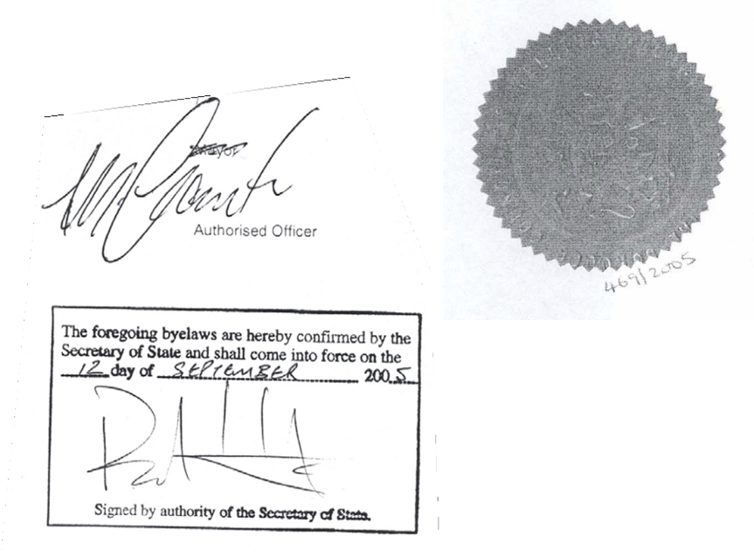

Fares currently set as:

If the distance does not exceed 541.54 yards:-
for the whole distance £2.30

If the distance exceeds 541.54 yards:-
for the first 541.54 yards £2.30
for each subsequent 117.33 yards 10 pence

Waiting Time

For each period of 35 seconds or uncompleted
part thereof including periods during the journey
when the vehicle is stationary 10 pence

Extra charges

For hirings begun between 6am and 11pm on a Sunday 25% of the fare
For hirings begun between 11pm and 6am 50% of the fare
For hirings begun on Bank Holidays 50% of the fare

For hirings begun between 6pm on Christmas Eve
and 6am on the day following Boxing Day and 6pm
on New Year's Eve and 6am on the day following
New Year's Day 100% of the fare

When conveying more than 4 passengers between the
hours of 6am and 11pm to increase the fare by 50%

When conveying more than 4 passengers between the
hours of 11pm and 6am to increase the fare by 100%

Only one of the above extra charges is permissible at any time

Journeys ending outside the Borough of Wellingborough will be metered unless an
alternative tariff is agreed prior to the commencement of the journey.

No charge in excess of fifty pounds (£50) shall be made in the event
of any hirer causing any damage to or soiling the vehicle hired in
any way whether by vomiting, urinating, spitting or otherwise.

