North Northamptonshire Housing and Employment Land Availability Assessment (HELAA):
Methodology Statement (January 2022)

North Northamptonshire Council: HELAA Methodology Statement
(January 2022)
1. Disclaimer
1.1 It is important to note that the Housing and Employment Land Availability Assessment (HELAA) does not determine whether a site should be allocated for development within the Local Plan or granted planning permission. All planning applications, including those for residential development, will be determined in accordance with the development plan unless material considerations indicate otherwise.
1.2 The inclusion of sites with potential for a particular use within the HELAA does not preclude their use or development for other uses.
1.3 The HELAA uses the information available at the time of preparation. Applicants for planning permission are advised to carry out their own assessments and analysis of site(s) and not only rely on information within this HELAA.
2. Methodology Statement
2.1 The purpose of this methodology statement is to establish how land availability will be assessed in the North Northamptonshire HELAA in the context of the National Planning Policy Framework (NPPF) and National Planning Practice Guidance (NPPG). It details the exact stages the Council proposes to follow in preparing the HELAA and provides context as to how each will be addressed.
2.2 For completeness, this Statement is issued alongside the Council’s Call for Sites (which seeks to identify sites for potential inclusion in the HELAA). This is being undertaken in tandem to allow the Council to collate feedback as one information gathering exercise whilst consultee focus is on the HELAA, reducing consultation fatigue and enabling feedback to be front loaded in the process. In following this approach, it is hoped this element of the HELAA can be signed off early to enable HELAA production to proceed without delay.
2.3 Further to this, the Council seeks feedback on the appropriateness of the proposed methodology within. A feedback form is both available at the end of this document (page 22) and on the Council’s consultation hub. If you do wish to provide feedback please can completed questions be returned by emailing the Council at planningpolicy@northnorthants.gov.uk by Monday 25th April 2022.
3. Introduction
3.1 The HELAA is a technical study focussed on the assessment of land availability. The purpose of the HELAA is to identify a future supply of land which is suitable, available and achievable for housing and economic development to provide an evidence base for potential site allocations in the Local Plan (and other statutory planning documents). It also seeks to establish assumptions about the development potential of land and realistic timescales for when this may come forward.
3.2 The HELAA is a key component of the evidence base that will inform the preparation and development of options for the North Northamptonshire Strategic Plan (NNSP). It will determine whether there is sufficient land to meet local housing needs (LHN) and where this could be located. The HELAA will also inform the preparation of other Development Plan Documents (DPDs) and Neighbourhood Plans (NP).
3.3 For the purposes of the HELAA, housing development is defined as sites for all types of housing, including housing for older people and student accommodation. Economic development refers to all employment uses, not just those within B use classes. This also includes main town centre uses as defined within Annex 2 of the National Planning Policy Framework (NPPF).
3.4 The HELAA is proposed to cover the period up to 2041 to accord with the proposed timeframe for the North Northamptonshire Strategic Plan (or NNSP – the Part 1 Local Plan for the area). It will also consider longer term development opportunities up to 2050 in order to align with the time horizon of the Oxford-Cambridge Arc Spatial Framework.
3.5 The main purpose of the HELAA is to perform the following functions:
- Identify sites and broad locations with potential for development;
- Assess and provide an indication of their development potential;
- Assess their suitability for development and the likelihood and timing of development coming forward (availability and achievability).
3.6 This approach ensures that all land with development potential is assessed so that the most suitable and deliverable (achievable) sites are identified. This will assist the local authority in maintaining an adequate supply of land to meet identified local needs, particularly for housing.
3.7 As outlined at para 1.1, the HELAA does not allocate land for housing or economic development. The HELAA provides information on the range of sites which are available to meet identified needs. These sites will then be assessed further and, where appropriate, allocated in the NNSP, DPDs or NPs.
3.8 Furthermore, the inclusion of a site in the HELAA does not mean that planning permission will be granted if any specific development proposals come forward. Any proposed development must be considered against the policies in the Development Plan and other material considerations through the planning application process.
4. Policy Context
National Planning Policy Framework (NPPF)
4.1 The NPPF confirms that the “preparation and review of all policies should be underpinned by relevant and up-to-date evidence. This should be adequate and proportionate, focused tightly on supporting and justifying the policies concerned, and take into account relevant market signals”.

4.2 The NPPF also requires that local authorities develop strategic policies “to provide a clear strategy for bringing sufficient land forward, and at a sufficient rate, to address objectively assessed needs over the plan period, in line with the presumption in favour of sustainable development.”
4.3 Linked to the above, the NPPF states at paragraph 68:
“Strategic policy-making authorities should have a clear understanding of the land available in their area through the preparation of a strategic housing land availability assessment, From this, planning policies should identify a sufficient supply and mix of sites, taking into account their availability, suitability and likely economic viability.”
4.4 The HELAA forms part of the evidence base to develop these strategic and other planning policies and to help deliver the requirement for Local Plans to make sufficient provision for housing (including affordable housing), employment, retail, leisure and other commercial development. In respect of housing, NPPF paragraph 60 states “…it is important that a sufficient amount and variety of land can come forward where it is needed, that the needs of groups with specific housing requirements are addressed and that land with permission is developed without unnecessary delay”. For economic uses the NPPF states that “significant weight should be placed on the need to support economic growth and productivity taking into account both local business needs and wider opportunities for development”. Furthermore, planning policies should “set out a clear economic vision and strategy which positively and proactively encourages sustainable economic growth” and “…identify strategic sites for local and inward investment”
National Planning Practice Guidance (NPPG)
4.5 In March 2014 the Government published the NPPG which expands upon, and provides practical guidance, to support implementation of the NPPF. The NPPG is regularly updated, with the latest guidance relating to the HELAA published in July 2019. Key extracts from the HELAA guidance is outlined below.
4.6 The HELAA guidance states that the purpose of the assessment is to identify a future supply of land which is suitable, available and achievable for housing and economic development uses over the plan period. The assessment of land availability includes strategic and local housing needs and land requirements as set out in the NPPF.
4.7 The NPPG outlines the inputs and processes which should lead to a robust assessment of land availability and states that plan-makers should have regard to the guidance in preparing their HELAAs. It also states that where plan-makers depart from the guidance, they will have to set out reasons for doing so.
5. Methodology
5.1 The methodology proposed for use in the North Northamptonshire HELAA is based upon that set out in the NPPG. In doing so, it is intended to follow each of the five stages the NPPG requires plan-makers to address in undertaking a HELAA. These Stages are shown in the Flowchart below (Figure 1). Further detail on each Stage, and how these shall be addressed by North Northamptonshire Council, is covered over the remainder of this section.

Figure 1: HELAA Method Flowchart (NPPG)
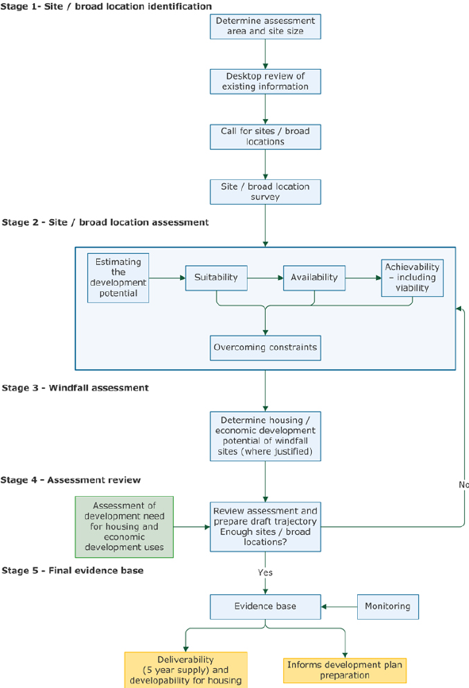

Stage 1 – Site / broad location identification
Site Assessment Area
5.2 The NPPG advises that the area covered by the HELAA should be the plan making area. It is therefore proposed that the geographical area for assessment is North Northamptonshire (the area comprising the former administrative areas of Corby, East Northamptonshire, Kettering and Wellingborough). For clarity, a map of the proposed assessment area is provided at Figure 2 below:
Figure 2: Map showing the proposed area to be covered by the HELAA
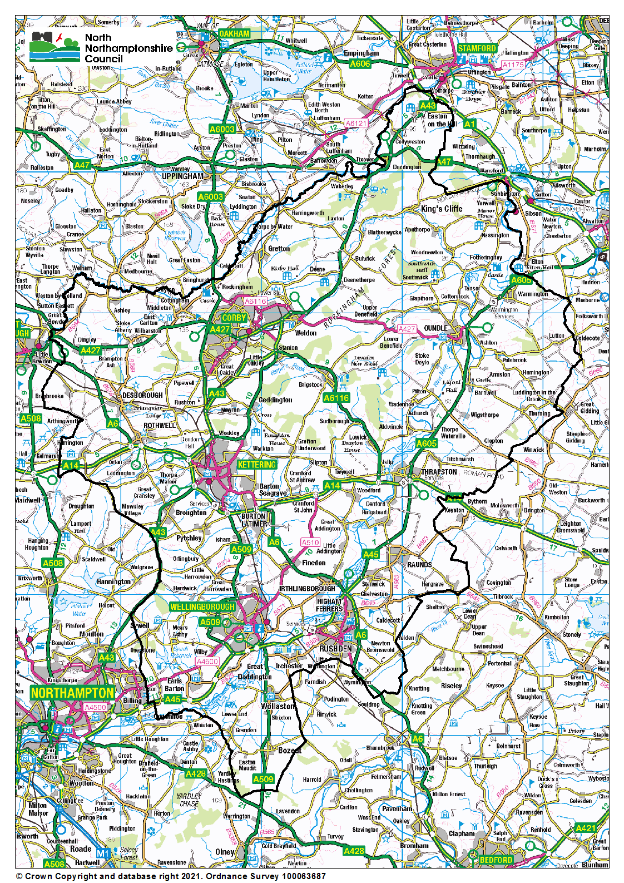
Site Size
5.3 As per the NPPF, it is proposed that the North Northamptonshire HELAA will consider sites for housing development which are capable of delivering 5 or more dwellings or sites for economic development uses of 0.25ha / 500sqm of floorspace and above. Sites of less than 5 dwellings will be considered as windfall development (see further detail on this at Stage 3 of this section).
Desktop review of Existing Information
5.4 The role of the HELAA is to ensure that local planning authorities have a robust understanding of the amount of land in their area which has the potential for accommodating housing and economic development uses. The NPPG outlines that to identify the most appropriate use for a site, it may be appropriate to carry out land availability assessments for housing and economic development uses as part of the same exercise.
5.5 In order to achieve this objective, the Council intends to follow the NPPG guidance by considering a wide range of sources to identify potential development sites. These are as outlined in Table 1 below (with locally derived additions underlined):

Table 1: Sources of data
Type of Site | Potential data source
Existing housing and economic development allocations and site development briefs not yet with planning permission | - North Northamptonshire Joint Core Strategy 2011-31 (July 2016)  - Adopted Part 2 Local Plans (including those submitted for Examination)  - Made and Draft Neighbourhood Plans  - Planning application records  - Development Briefs
Planning permissions for housing and economic development that are unimplemented or under construction | - Planning application records  - Development Monitoring records
Planning applications that have been refused or withdrawn | - Planning application records
Land in the local authority’s ownership | - North Northamptonshire Council Estates records
Surplus and likely to become surplus public sector land | - Register of Surplus Public Sector Land  - Homes England Land Hub  - Engagement with strategic plans / relevant departments of other public sector bodies such as Central Government, National Health Service, Police, Fire Services, Utilities services, statutory undertakers.
Sites with permission in principle and identified brownfield land | - Brownfield Land Register for North Northamptonshire  - Valuation Office Database  - Active engagement with sector
Vacant and derelict land and buildings  (Including empty homes, redundant and disused agricultural buildings, potential permitted development changes, e.g., offices to residential) | - Local authority empty property register  - English Housing Survey  - Commercial property databases  - Valuation Office database  - Active engagement with sector  - Brownfield Land Register for North Northamptonshire
Additional opportunities for un-established uses  (e.g., making productive use of under-utilised facilities such as garage blocks) | - Ordnance Survey maps  - Aerial photography  - Planning applications  - Site surveys  - Registered providers
Type of Site | Potential data source
Business requirements and aspirations | - Enquiries received by North Northamptonshire Council’s Economic Development team  - Active engagement with sector
Sites in rural locations | - Local and neighbourhood plans  - Planning applications  - Ordnance survey maps  - Aerial photography  - Site surveys
Large scale redevelopment and redesign of existing residential or economic areas
Sites in and adjoining villages and rural exception sites
Potential urban extensions and new free-standing settlements

Call for Sites
5.6 The NPPG details that a “Call for Sites” should be undertaken at Stage 1 of preparing the HELAA. The Council is addressing this through the Call for Sites exercise it is undertaking alongside consultation on this methodology statement. This Call for Sites exercise began on January 12th 2022 and runs until April 25th 2022. Details of this exercise have been sent to all entries on the Council’s Strategic Plan consultation database. This has been augmented through local publicity including publication on North Northamptonshire Council’s consultation hub. It is considered that alongside consideration of the data sources outlined at Table 1 above, this approach is both transparent and comprehensive in scope and should enable the Council to identify as many potential development opportunities as possible.
Site review
5.7 Having collated a list of potential development sites from the sources listed in Table 1 above, an initial desktop review shall be undertaken to sift out those sites that should be excluded from assessment. This shall be done to reduce the need to assess sites later in the process which are unacceptable in principle. Table 2A outlines the basis on which sites will be excluded initially – namely if they fall below the size threshold or are located outside the Local Plan area (i.e., North Northamptonshire):

Table 2A: Sites Not Considered
Category | Reason(s) | How it will be identified
Sites of less than 5 dwellings or under 0.25ha (or 500m2 of floorspace) for economic development uses. | Sites below these thresholds are not considered eligible for assessment in the HELAA in accordance with the NPPG.  This threshold is also consistent with the approach taken by the West Northamptonshire Joint Planning Unit (now West Northamptonshire Council) in preparing their HELAA in 2020. | Information submitted through Call for Sites exercise.  Where site capacity has not been identified it is proposed to use a standard density of 30dph on 60% of the site area as an approximation to determine eligibility for residential development. This calculation shall be refined as applicable as sites progress through the assessment stages (for example, to take constraints into account).  For sites where employment uses are proposed and no plot sizes or ratios ae provided, it is proposed to use a standard assumption of 40% developable area to determine eligibility for inclusion in the HELAA (subject to the same caveats as outlined above).
Sites outside the Local Plan area | The HELAA will only assess sites located within North Northamptonshire. This will include sites submitted which are partially located in the local authority area. | Site boundaries/polygon and/or GIS analysis

Sites Not Assessed
5.8 The NPPG advises that sites in existing development plans (i.e., allocations) and those with an existing planning permission should be included in the HELAA, although it may be necessary to assess whether circumstances have changed which may affect their suitability (including market signals and considering use of the land for alternative uses). In light of this, it is proposed that the HELAA records those sites, and capacities, which benefit from an existing permission and/or allocation but does not undertake further detailed assessment, unless new information is made available which materially changes previous agreed assumptions for the reasons outlined at Table 2B:
Table 2B: Sites Not Assessed
Category | Reason(s) | How it will be identified
Sites with existing planning permission or under construction (unless new information is made available). Further details on the proposed approach are provided at para 5.16 of Stage 2 below. | Sites with extant planning permission are thoroughly and publicly assessed and the granting of consent for development is an indication these are considered suitable, achievable and deliverable for the specified yields and uses. | Planning permission records and Monitoring / Authorities’ Monitoring Report
Sites allocated in the Part 1 Local Plan, Part 2 Local Plans and Neighbourhood Plans (unless new information is made available) | Sites allocated for development within the Development Plan have been subject to thorough testing and passed through a detailed examination process to confirm these are considered suitable, achievable and deliverable for the specified yields and uses. | Development Plan Documents

5.9 Notwithstanding this, however, it is the intention to review sites already in the planning process through Stage 2 of the HELAA assessment process if new information is made available to the Council on these sites with potential examples being changes to a site boundary, proposed use or yield, or new information about developability.
5.10 It is proposed that sites that are excluded at this Stage will be recorded along with the reasons for their exclusion. Sites which remain after this sieving process shall be surveyed through Stage 2 of the assessment process, with details on this provided below.

Stage 2 – Site/broad location assessment
5.11 Stage 2 of the HELAA process involves assessing whether a site is ‘suitable’ for the type of development proposed, ‘available’ and ‘achievable’. Information on suitability, availability and achievability will be collected and analysed through a combination of desktop assessments and the information submitted by landowners, agents, developers and other interested parties in response to the call for sites process.
5.12 When considering this Stage of assessment, the NPPG outlines that:
“a site or broad location can be considered suitable if it would provide an appropriate location for development when considered against relevant constraints and their potential to be mitigated”.
5.13 More detailed considerations such as economic viability, market attractiveness and how constraints such as nature, heritage conservation and landscape impacts could be overcome are also introduced at this stage.
5.14 Further to this, the remainder of this section outlines how the Council proposes to address Stage 2 of the assessment.
Suitability
5.15 National Planning Practice Guidance advises that a site or broad location can be considered suitable if it would provide an appropriate location for development when considered against relevant constraints and their potential to be mitigated or overcome. These may include:
- Information collected as part of initial site surveys
- National policy
- Appropriateness and likely market attractiveness for the type of development proposed
- Contribution to regeneration priority areas
- Potential impacts of development upon landscapes (including landscape features), nature and heritage conservation
- Physical limitations or problems such as access, infrastructure/utilities, ground conditions, flood risk, pollution or contamination.
5.16 The NPPG also advises that sites in existing development plans or with planning permission can generally be considered suitable for development. It is therefore proposed that these sites will not be considered further in the HELAA, other than being recorded, with the focus instead on new sites for future delivery. However, the NPPG advises that there may be instances where review of these sites will be necessary to assess whether circumstances have changed for sites already in the planning process which could impact their suitability. Where this is so, it is proposed that relevant sites are assessed on an individual basis (see para’s 5.8 - 5.10).
Availability
5.17 National Planning Practice Guidance advises that a site should be considered available for development when, on the best information available (such as from call for sites information), there is confidence that there are no legal or ownership impediments to development and the landowner (or developer) has expressed an intention to develop. The information received through the call for sites process will be used to determine this alongside a desktop review to determine whether planning permission exists.
Achievability
5.18 National Planning Practice Guidance advises that a site should be considered achievable for development where there is a reasonable prospect that the particular type of development will be developed on the site at a particular point in time. This is essentially a judgement about the economic viability of a site.
5.19 In carrying out this element of the assessment, the call for sites form includes a number of questions for site promoters to advise on which are intended to provide clarity on land ownership and if there are any challenges to be overcome to bring the site forward. In addition to the information supplied by the site promoters, it may be necessary for the Council to procure viability advice through the use of independent consultants and/or documented advice from other sources to help determine whether proposals for a site are economically viable in the context of site-specific information gathered. Sites with planning permission will be considered deliverable for the purposes of the HELAA unless more recent information indicates otherwise.
5.20 Sites that are rejected because they are not suitable, available or achievable will be listed in the HELAA. Sites where insufficient information has been gathered to undertake assessment shall also be listed.
5.21 The sites which remain will be considered deliverable or developable and shall also be listed in the HELAA. For these sites information about site capacity and delivery timescales shall be provided (further information on proposed HELAA outputs is provided at Stage 5 of this paper).

Outputs
5.22 The information on suitability, availability and achievability will be used to assess the deliverability of each site and identify the timescales in which each site could be delivered. Each site will be categorised as either:
- Deliverable (i.e., it is available now, at a suitable location and there is a reasonable prospect that development could commence on the site within 5 years)
- Developable (i.e., it is a suitable location and there is a reasonable prospect that it will be available and could be delivered over the remainder of the plan period).
- Not developable
Overcoming constraints
5.23 The NPPG states that where constraints have been identified, the assessment will need to consider what action could be taken to overcome them (along with when and how this could be undertaken and the likelihood of sites/broad locations being delivered).
5.24 The outcomes of the Suitability, Availability and Achievability assessments (outlined above) will be set out within the HELAA. This will include a separate schedule of sites which assessment has deemed to be “not developable” based on current evidence. The constraints identified for each site shall also be outlined and, where possible, the action(s) needed to overcome them.
Garden Villages/New settlements
5.25 Sites that are promoted as Garden Villages/new settlements will be assessed against the criteria proposed above. However, the complexities in bringing such sites forward, and therefore lead-in times, may mean these sites do not receive the highest scores in terms of availability and achievability.
Estimating development potential – Residential sites
5.26 For each of the sites identified, it is necessary that the HELAA details how many houses (yield) could be delivered. It is proposed that where a site promoter has provided an indicative scheme, or suggested a specific number of dwellings that are expected to be delivered on a site, then these figures will be used in the first instance. It is proposed that the same approach shall be used where a site has been allocated for housing in the development plan or benefits from an extant planning permission.
5.27 Where yield is not provided, it is proposed the Council follows a slightly amended version of the methodology used in the North Northamptonshire Strategic Housing Land Availability Assessment (SHLAA). These amendments are proposed to take account of policy changes since the SHLAA was published and local experience.
5.28 To calculate yields on this basis, a number of steps are proposed, as outlined between para’s 5.29 and 5.37 below.
Gross Site Area
5.29 The gross area of the site is the area of the site polygon measured in hectares using GIS.
Permanent features factor
5.30 Once the gross site area is established, it is proposed that a factor is then applied to represent the percentage of the gross site area likely to be available for housing development after taking account of any site-specific capacity constraints which may exist. These constraints could relate to site shape, topography or features that should remain such as existing buildings or infrastructure. For example, if a proposed site contained a water body within its confines, the gross site area available for development purposes would be reduced / discounted by applying a permanent features factor (e.g., this water body may comprise 20% of the proposed site so it is assumed that only 80% of the site will be available for development purposes, meaning any yield calculations would be based on 80% of the calculated gross site area).
Gross to net factor
5.31 Application of a gross to net factor is then proposed to take account of the need for development to provide supporting facilities on site. For example, large sites are expected to provide significant on-site infrastructure such as schools, community facilities, green spaces etc. In contrast, smaller sites are expected to have less infrastructure requirements and the smallest sites are likely to have no need to provide infrastructure on site. On this basis, the following gross to net ratios are proposed:
Site Size | Gross to Net Ratio
Up to 0.4 hectares | 100%
0.4 to 2 hectares | 90%
2 to 10 hectares | 75%
Over 10 hectares | 50%

Mixed Use Factor
5.32 Some sites will be promoted for a mix of uses. This could be horizontally with an area of the site used for non-residential uses or vertically where residential uses are anticipated on upper floors and non-residential on the ground floor. In cases where a mixed-use site has been proposed, or identified, as the most appropriate use(s) for a particular location, where this has not been provided through site submissions, the intention is to apply a mixed-use factor to reflect that a site will not be used 100% for housing development and to reduce the area (and potential yield) associated with it. It is expected that proposals for mixed use developments will typically be located in town centres. As a notional approach it is proposed that a 75% mixed use factor is applied in sites located in the Growth Towns with this reducing to 50% elsewhere (broadly consistent with para 4.35 of the 2009 SHLAA).
Net density
5.33 In determining the appropriate density that should be applied to a site, regard needs to be had to:
- The need to use land efficiently, thereby reducing the amount of greenfield land lost;
- The need to provide for a mix of housing types, sizes and styles to meet local needs (this will include the need for specialist housing);
- The characteristics of the surrounding area;
- The desirability of achieving high quality, well-designed housing; and
- The need to focus development in the most sustainable locations and to actively manage patterns of growth to make the fullest use of public transport, walking and cycling.
5.34 The NPPG requires that the development potential of each site is calculated as part of the assessment process and this can be guided by existing or emerging plan policies including those on density. Para. 4.9 of the North Northamptonshire Joint Core Strategy advocates a design-led approach as most appropriate to determining densities on a site-by-site basis having regard to the objective of securing the efficient use of land and the particular characteristics of a site and the area in which it is located. This is supplemented at Policy 8c ii (Place Shaping Principles) which states development should ensure adaptable and flexible spaces by mixing land use and densities within settlements. There is therefore no longer any national guidance on appropriate housing densities, nor are any minimum or maximum density standards set within the development plan.
5.35 Taking this into account, it is proposed that the following net density rates will be used for the HELAA, based on the rates previously applied in the 2009 SHLAA:

Site Location | Density  (net dwelings per hectare)
Within the town centre of a Growth Town | 100
Within 400m of the town centre of a Growth Town or within the defined town centre of the Market Towns | 50
Elsewhere across the area | 35

Calculating Housing Capacity
5.36 Following the steps outlined at paragraphs 5.26 – 5.34 above, it is proposed that the data generated will be used to calculate the housing capacity of a site through application of the formula below:
Gross site area x permanent features factor x gross to net factor x mixed use factor x net density
=
potential housing capacity
5.37 Following this approach will provide a site housing yield which can be used to inform the HELAA. However, it is recognised that this figure will need to be mindful of the surrounding area and existing uses. In order to allow sufficient flexibility it is proposed that each housing capacity figure is subject to a ‘reality check’. For example, if the site is in an area of low density characterised by large properties then the site would be likely to be developed at a similar density meaning it may be necessary to revise the potential capacity downwards to reflect a scheme that is likely to be acceptable. Similarly, if a scheme outside a town centre is proposed for flats/apartments to meet the need for smaller homes, or is identified for specialist housing such as a care home, then the density might reasonably be revised upwards.
Estimating development potential – Employment sites
5.38 It is proposed that when considering the potential yield of employment sites that information submitted by site promoters shall be used in the first instance, where applicable. This approach is consistent with that proposed when considering sites submitted for housing development (see para 5.26) and ensures that a developer’s/landowner’s/agent’s aspirations for the site are correctly reflected in the HELAA.
5.39 Where this information is not available, it is proposed that the HELAA will use a net developable area of 40% to calculate employment floorspace. In doing so this figure assumes that 60% of a site proposed for employment purposes is taken up (or discounted) through features expected of new development such as access, landscaping and drainage, with the remaining (residual) amount (40%) being taken up by new buildings on site.
5.40 This approach is consistent with the technical note previously developed by the NNJPDU to translate job targets identified in the Joint Core Strategy into employment land requirements and is proposed as acceptable for a HELAA, which is strategic in scope as it permits a consistent and straightforward approach to be applied.
5.41 If sites identified through the HELAA are progressed for further consideration as part of developing the North Northamptonshire Strategic Plan, then it is expected the approach as outlined will be reviewed and refined as part of this process, including the requirement to make efficient use of land.
Stage 3 – Windfall assessment
5.42 The NPPF defines Windfall sites as “sites not specifically identified in the development plan”. Both the NPPF (para 71) and NPPG address how these sites can be treated when considering future housing supply, outlining that an allowance for such sites can be made if the local planning authority has compelling evidence that they will provide a reliable source of supply to justify their inclusion. To do so, it is made clear that this allowance should be realistic, having regard to the strategic housing land availability assessment (SHLAA), historic windfall delivery rates and expected future trends. NPPF Paragraph 69 (c) supports the development of windfall sites through policies and decision making.
5.43 Since the North Northants SHLAA was published in May 2013 the definition of windfall development has changed and this will be taken into account in analysis of this element of housing supply / HELAA Stage 3. Previously, windfall was calculated on the basis of what development had occurred on previously developed (brownfield) sites of 0.25ha and below. However, changes to national policy and guidance since 2013 has amended this, with unallocated completions on both greenfield sites and residential gardens now included in these figures.
5.44 To generate the evidence required for Stage 3 assessment, it is proposed that windfall data will be initially collated on an area basis which corresponds with the former local authority areas of Corby, East Northamptonshire, Kettering and Wellingborough. This will then enable an aggregate figure for North Northamptonshire to be identified, aligning with the scope of the HELAA and spatial remit of the Council.
5.45 It is then proposed that the annual windfall allowance will be calculated through applying a trend-based approach based on analysis of completions over a ten-year period 01/04/2011 - 31/03/2021, with the former representing the start of the plan period of the current Part 1 Local Plan (the North Northamptonshire Joint Core Strategy) and the latter the end date of the latest monitoring year (2020/21). If, upon review, the evidence suggests an allowance is justified, then it is proposed that this will be included in the HELAA from year 6 onwards, consistent with advice in the PPG and in part to avoid double counting against unimplemented planning permissions.
Stage 4 – Assessment Review
5.46 National Planning Practice Guidance advises that once the sites and broad locations have been assessed, the development potential of all sites can be collected to produce an indicative trajectory which sets out how much housing and economic development, and other uses, can be provided, and at what point in the future (i.e., within years 1 to 5, 6 to 10 and 11 and beyond).
5.47 Following this process, if this indicative trajectory indicates that insufficient sites have been identified to meet the (as yet undetermined) objectively assessed needs of North Northamptonshire for housing and employment purposes, the Council will need to revisit the HELAA assessments. This may entail a review of the assumptions made regarding density and yield assessment (i.e., the development potential) of sites to ensure the most efficient use of land is being sought or even require a further call for sites exercise. If, following additional review, a shortfall remains relative to development needs, it will be necessary to consider how this could be planned for, including liaison with local authorities which adjoin North Northamptonshire pursuant to the Duty to Cooperate.
Stage 5 – Final Evidence Base
5.48 Once the HELAA has been completed, following the Stages outlined above, it will be published and form part of the evidence base produced to inform the NNSP and associated Local Plans including Neighbourhood Plans. As directed in the NPPG, the HELAA will provide a set of standardised outputs, including a list of all sites considered through assessment which are cross-referenced to maps showing their location. These outputs will also make clear:
- Those sites rejected at Stage 1 including reasons why;
- Those sites considered suitable, available and achievable and the potential type and quantity of development, including estimates of build out rates, any barriers to delivery and whether and when these could be overcome;
- Any sites considered to meet the needs of North Northamptonshire but which may be located outside the local authority area;
- An indicative trajectory of anticipated development as derived through assessment

5.38 The HELAA, at all relevant stages, including the finalised version, shall be made publicly available to view on North Northamptonshire Council’s website. This shall include subsequent reviews and updates as necessary.

North Northamptonshire HELAA – Approach to Methodology (January 2022): Comments and Feedback
- Your Contact Details
1 |  | Title:
2 |  | Full Name:
3 |  | Position (if relevant):
4 |  | Organisation / company:
5 |  | Your Address: | Line 1
 |  |  | Line 2
 |  |  | Line 3
 |  |  | Line 4
6 |  | Postcode:
7 |  | Telephone Number:
8 |  | Email address:
9 |  | Please select the role(s) which best describes yourself: |  |  |  | Owner of the site |  | Registered Social Landlord
 |  |  |  |  |  | Land Agent |  | Developer
 |  |  |  |  |  | Planning Consultant |  | Local Builder
 |  |  |  |  |  | Acting on behalf of the site owner(s) |  | Public land-owning body
 |  |  |  |  |  | Other*
*If Other is selected, please specify your role (e.g., a third party; Parish Council etc):
10 | Date:

General Data Protection Regulations
To see more about how we record and store your information please see North Northamptonshire Council’s Corporate Privacy Notice: https://www.northnorthants.gov.uk/your-council/corporate-privacy-notice

Notes
- Please insert reference to relevant paragraph (where necessary).
- Please can completed questions be returned to the Council at planningpolicy@northnorthants.gov.uk by Monday 25th April 2022.

B class uses or equivalent categorisation under the Town and Country Planning (Use Classes) (Amendment) (England) Regulations 2020 which came into effect on 1 September 2020 and includes a transitional period.
NPPF (2021) paragraph 31
NPPF (2021) paragraph 23
NPPF (2021) paragraph 20
NPPF (2021) paragraph 81
NPPF (2021) paragraph 82 (a)
NPPG (2019) Reference ID: 3-001-20190722
NPPF (2021) paragraphs 23, 60 and 68
NPPF (2019) Reference ID: 3-004-20190722
NPPG (2019) Reference ID: 3-009-20190722
NPPG (2019) Reference ID: 3-001-20190722
NPPG (2019) Reference ID: 3-011-20190722
NPPG (2019) Reference ID: 3-012-20190722
NPPG (2019) Reference ID: 3-018-20190722, 3-019-20190722
NPPG (2019) Reference ID: 3-018-20190722
NPPG (2019) Reference ID: ID: 3-018-20190722
This entry outlines locally identified factors which may also need consideration when assessing site constraints (this list is not exhaustive).
This includes allocations in made Neighbourhood Plans and those with a published Decision Statement)
NPPG (2019) Reference ID: 3-018-20190722
NPPG (2019) Reference ID: 3-019-20190722
NPPG (2019) Reference ID: 3-020-20190722
This is applied to the residual site area calculated following application of the permanent features factor described at para 5.30.
Where a site is proposed wholly for housing a 100% mixed use factor would be applied in this instance
At Table 4.5
North Northamptonshire Joint Planning Unit (2008) Technical Note for partner Local Planning Authorities o translation of job numbers into employment land requirements (Online) Available at: http://www.nnjpu.org.uk/docs/Turning%20%20Employment%20Numbers%20into%20Land%20Quantities.pdf
NPPF (2021) Section 11 (Making Effective Use of Land) and para 124 a) – e)
NPPF (2021): Annex 2: Glossary
This end date may be extended to 31/03/2022 dependent on data availability.

